**User Manual:**

Setting Organisation API Operator Password

Contents

Revision Log 3

1. Introduction 4

2. Creation of API Operator 5

3. Setting the Password: 9

# Revision Log

|  |  |  |  |
| --- | --- | --- | --- |
| **Revision Number** | **Revision Date** | **Revision** | **Revision made by** |
| 1.0 | 19th April 2015 | Initial Draft | Eneth Kubai |

# Introduction

The API password is the key to sending API transactions to M-Pesa. The system administrator of the organization or a Safaricom Support Engineer can create the API operator on the web and give a web operator permission to set the API password. The API Password is set on the web and then input on the API Request. The API password must be encrypted with the caller public key before being passed in the Generic API Request.

If the password is disclosed or cracked, system security is threatened. Therefore, password protection is important.

# Creation of API Operator

1. The Business Administrator logs in to the organization web portal. Click on **My Functions**, then click **Operator Management**.

URL: <https://org.ke.m-pesa.com/>

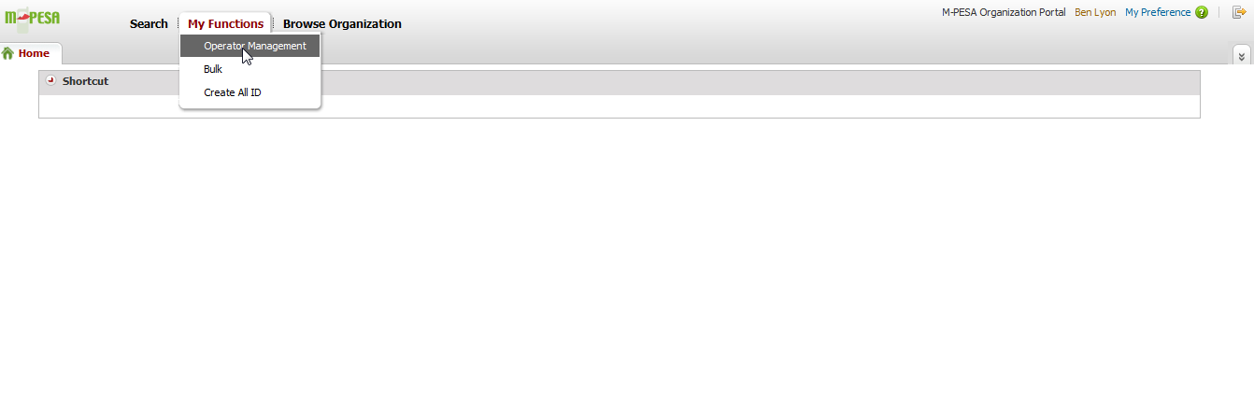

1. The Operator Management tab appears. Click the **Add** button.

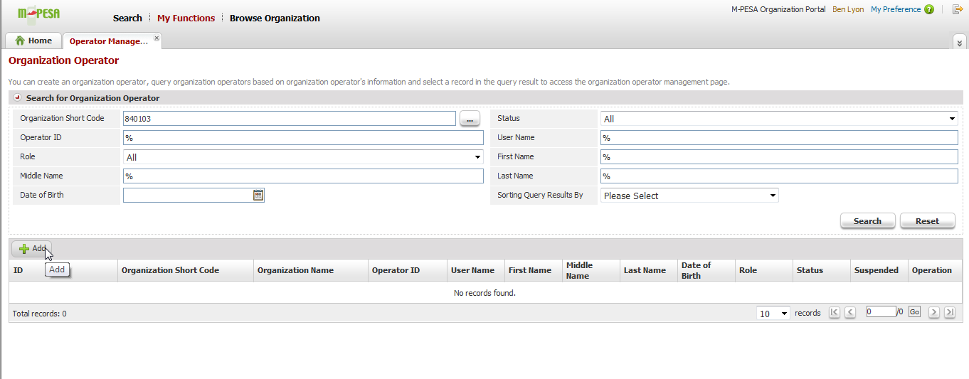

1. This page is displayed.

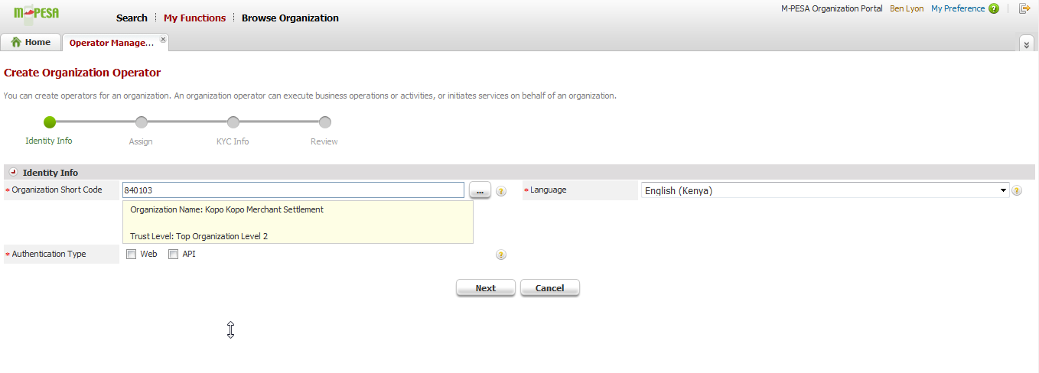

1. Select **API** and enter the preferred API **Username**. The username is the value used in the Initiator.Identifier tag in the generic API request. The username should be less than 16 characters. After entering the Username click **Next**.

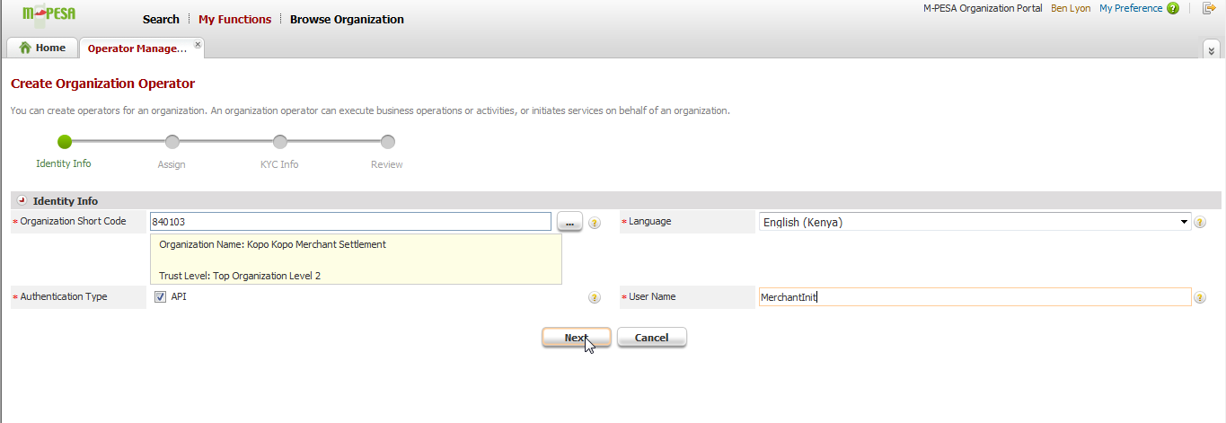

1. On the next page choose **Web Operator Rule Profile** in the **Rule Profile** tab. Then Click the **Add** button. A drop down menu will be displayed. Choose **ORG B2C API initiator**, **Transaction Status Query ORG API** and **Balance Query ORG API** and click **OK**.

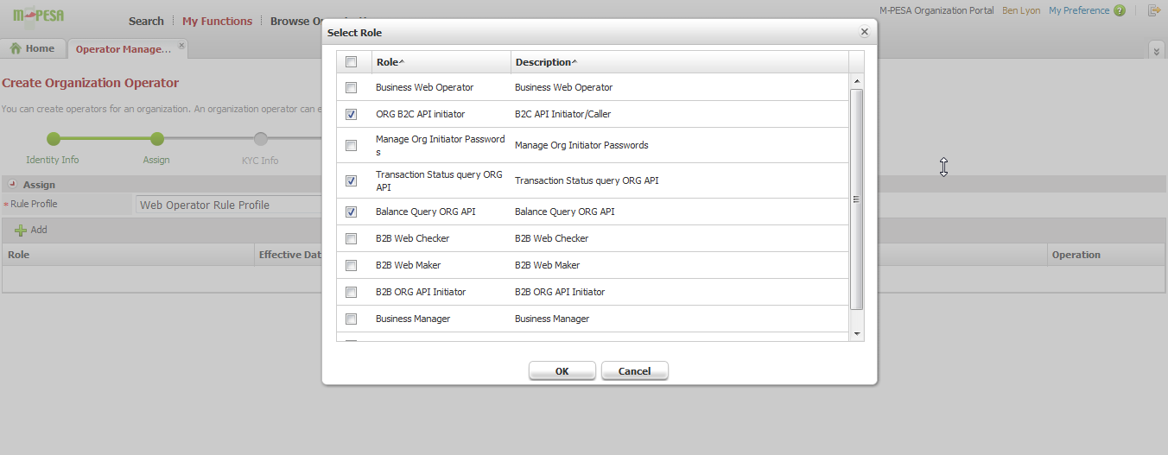

1. Click **Next**.

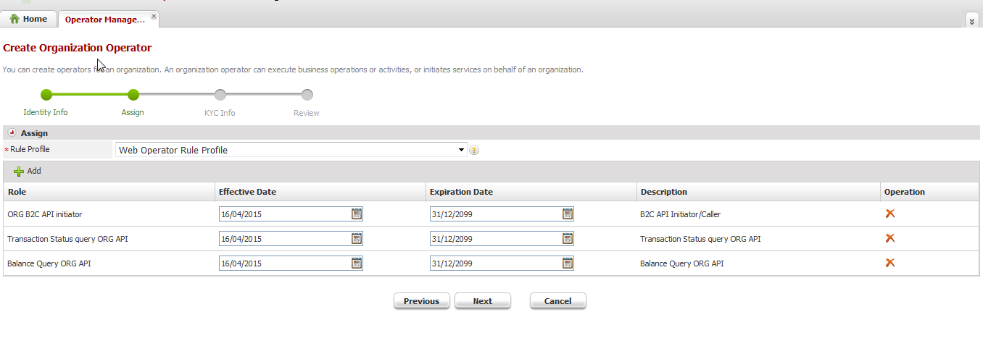

1. Enter the operator details and click **Next**.

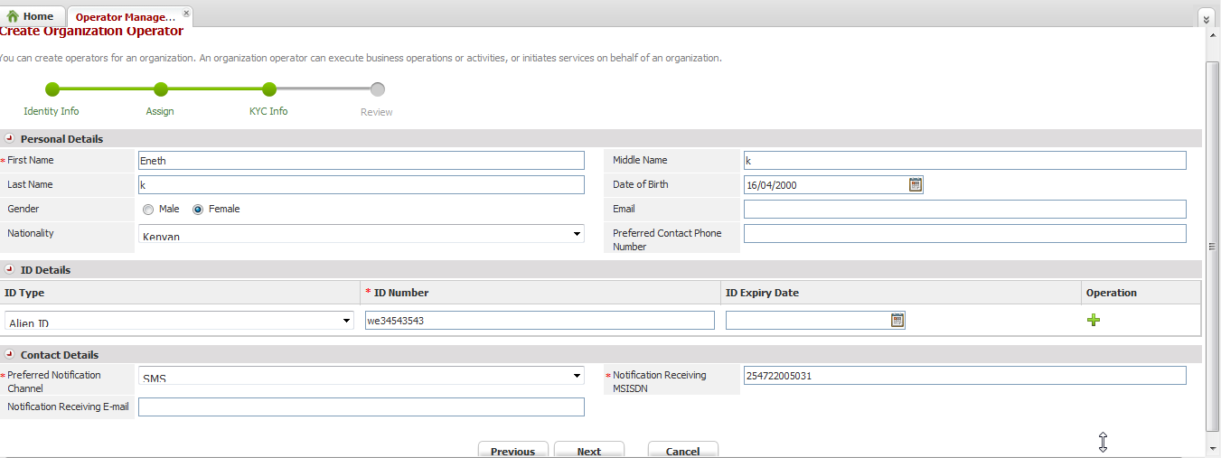

1. On the next page confirm the operator details and click **Submit**.

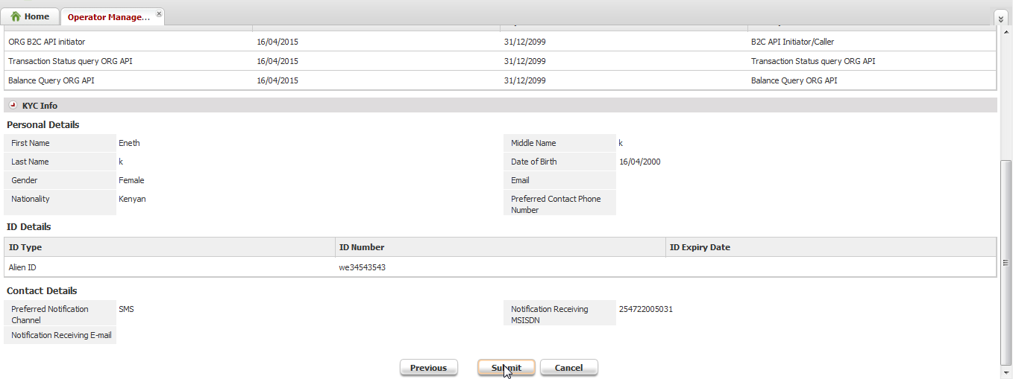

# Setting the Password:

1. The first step is ensuring that the web Operator has the correct role (Set Restricted ORG API PASSWORD). The web operator with the correct role logs in and clicks **Search**, then clicks **Operator**. The operator should then enter the API Username in the Username field and Click **Search**.
2. When the Operator details are displayed, click the icon in the Operation column.

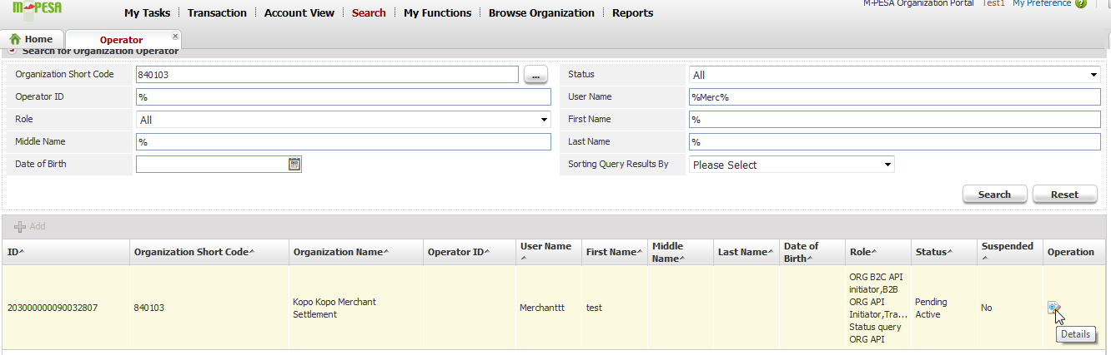

1. The API Operator details will be displayed. Click the **Set Password** button.

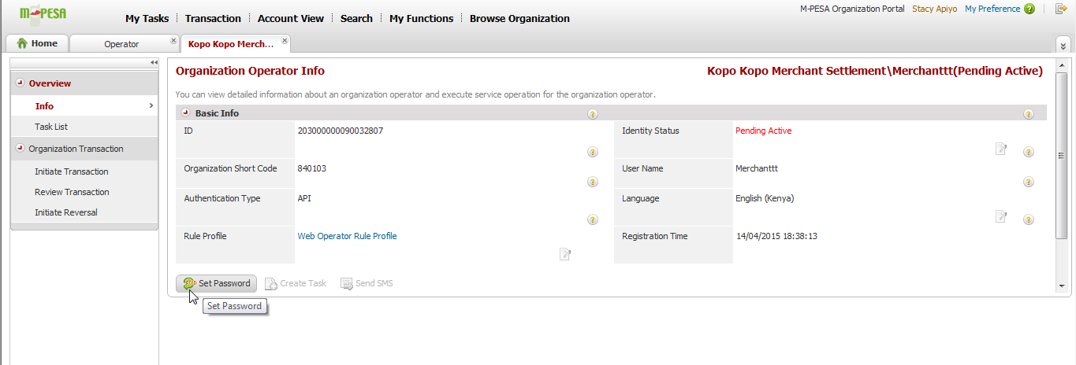

1. Enter the preferred password. (Must contain a capital letter, small letter, number and special character)

